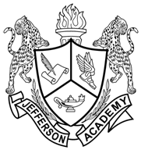
Jefferson Academy
Class of 2017
Quick College Application Info
(Use for College Applications)

Jefferson Academy High School Code | 060-161
School Address and Phone | 11251 Reed Way  Broomfield Colorado 80020  720-887-1992
2017 Senior Class Size | 102
College Courses offered at JAHS  (Front Range Accredited Site)  Number includes two CCU courses and two CU Succeed Courses | 18 courses offered on JAHS campus  Students may also take courses at the colleges
Advanced Placement Courses offered at JAHS | 5
Honors Courses offered at JAHS | 9
Date student started 9th grade | August, 2013
Graduation Date | May 26, 2017

